Exp.No:5
Date:

1. Write a program that will increment a counter’s accumulated value 1 count every 60s. A second counter’s accumulated value will increment 1 count every time the first counter’s accumulated value reaches 60. The first counter will reset when its accumulated value reaches 60, and the second counter will reset when its accumulated value reaches 12.
2. Write a program to implement the process illustrated in Figure. The sequence of operation is to be as follows:
• Normally open start and normally closed stop pushbuttons are used to start and stop the process.
• When the start button is pressed, solenoid A energizes to start filling the tank.
• As the tank fills, the empty level sensor switch closes.
• When the tank is full, the full level sensor switch closes
• Solenoid A is de-energized.
• The agitate motor starts automatically and runs for 3 min to mix the liquid.
• When the agitate motor stops, solenoid B is energized to empty the tank.
• When the tank is completely empty, the empty sensor switch opens to de-energize solenoid B.
• The start button is pressed to repeat the sequence.
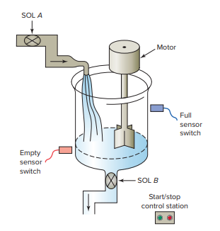

3. Write a PLC program to operate a light according to the following sequence.
- A momentary push button is pressed to start the sequence
- The light is switched ON and remains ON for 2 s.
- The light is then switched off and remains off for 2 s.
- A counter is incremented by 1 after this sequence.
- The sequence then repeats for a total of 4 counts.
- After the fourth count, the sequence will stop and the counter will be reset to zero.

4. A pump is to be used to fill two storage tanks. The pump is manually started by the operator from a start/stop station. When the first tank is full, the control logic must be able to automatically stop flow to the first tank and direct flow to the second tank through the use of sensors and electric solenoid valves. When the second tank is full, the pump must shut down automatically. Indicator lamps are to be included to signal when each tank is full. a. Draw a sketch of the process. b. Prepare a typical PLC program for this control process.

5. When the lights are turned off in a building, an exit door light is to remain on for an additional 2 min, and the parking lot lights are to remain on for an additional 3 min after the door light goes out. Write a program to implement this process.
6. Three conveyors feed a main conveyor. The count from each feeder conveyor is fed into an input register in the PLC. Construct a PLC program to obtain the total count of parts on the main conveyor. Use a timer to update the total every 15 seconds. Design, construct, and test PLC circuits for this process

